BRIEF HISTORY OF A CHILD’S ADMISSION AT BETHANY FAMILY.
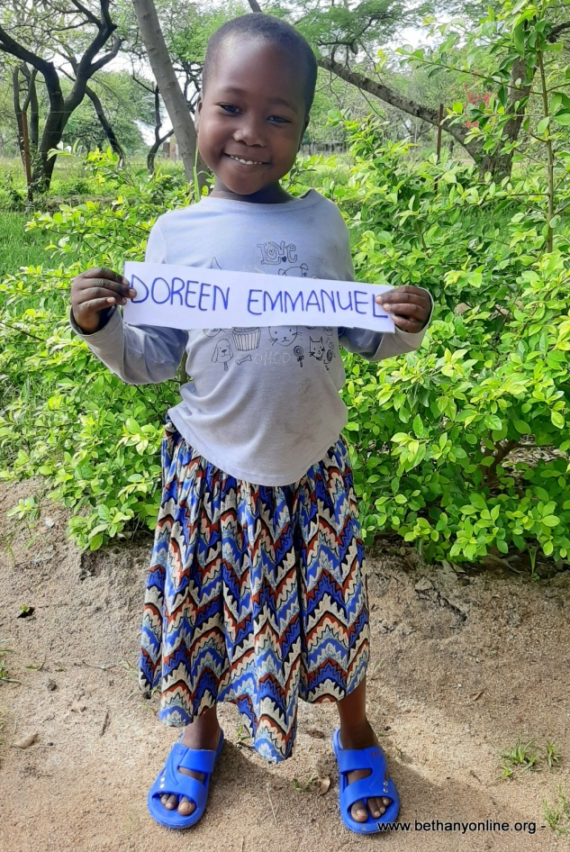
Full name: Doreen Emmanuel Helman
Fathers Name: Emmanuel Helman
Mother’s name: Kefleni Makoye
Date of Birth: 23/03/2014
Place of Birth: Busega (Buyorwa)
Date of admission: 01/11/2020
Reason of Admission: Orphan
Best colour: Pink
Favourite food: Ugali and Dagaa
Best friend: Misoji Mathias
Best subject: Numeracy
Tribe: Sukuma
Class: Toddlers
Sex: Female
Religion: Christian
Height: 100cm
Weight: 12kg

DOREEN EMMANUEL HELMAN’S STORY (A NAME GIVEN TO HER AT BETHANY)
Doreen has a twin sister named Dorcas at Bethany and another set of older twin brothers (Edson and Edwin). All four children are from the same parents. The mother has given birth to three sets of twins and four other children. Therefore, Doreen is one of ten children, though one has passed away.
The mother leaves in a very rural village next to Sogesca (where Bethany is) called Buyorwa. It is a place at the shore of the Lake Victoria and many people make their living through doing illegal fishing of small fish called sardines and other petty businesses. The place is overcrowded with very little for individuals to survive on.
Doreen’s mother was married but her husband passed away few years ago because of HIV (a disease which is very common in this area). Therefore, she was left with all these children to look after. She is illiterate herself and only one of her children goes to school. The church nearby where Emmakulatha Zephaniah (Our Bethany Headteacher) and her husband attend every Sunday, started a programme of going around and identifying children and families which they could help provide something basic such as nutritious food, shelter etc and they discovered Doreen’s family.
The pastor of the church helping these various families alongside Emmakulatha and her husband Zephaniah, went and saw the actual environment of these children and approached Miss Jesca Paulo (Bethany Project Director) and asked if we would be able to help this lady take care of some of her kids. Miss Paulo did some investigations of her own and was convinced of the situation. Some pictures have been attached to the story for you to see the actual environment Doreen and her fellow children were living in, and which her mother and other siblings are still living in as of today.
The children were very malnourished when they came to Bethany and were treated for things like roundworm and improved their diet. We are happy that they are settling into Bethany very well and coping with the environment. They have started going to school, though not officially but they are slowly getting into the routine and by next year, we’ll be able to register them officially and sort out their school uniforms etc.
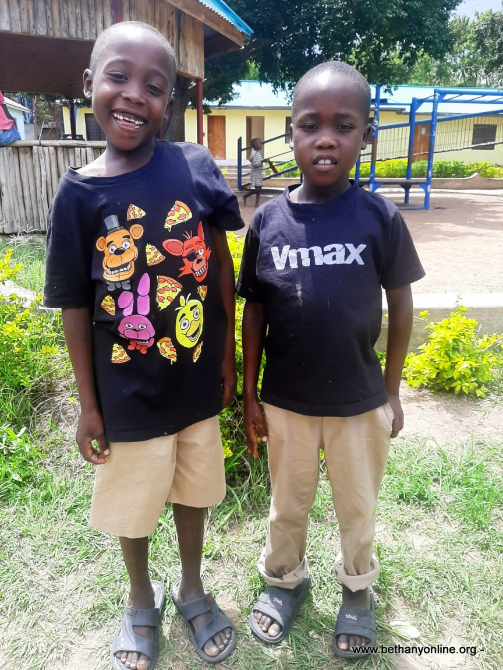
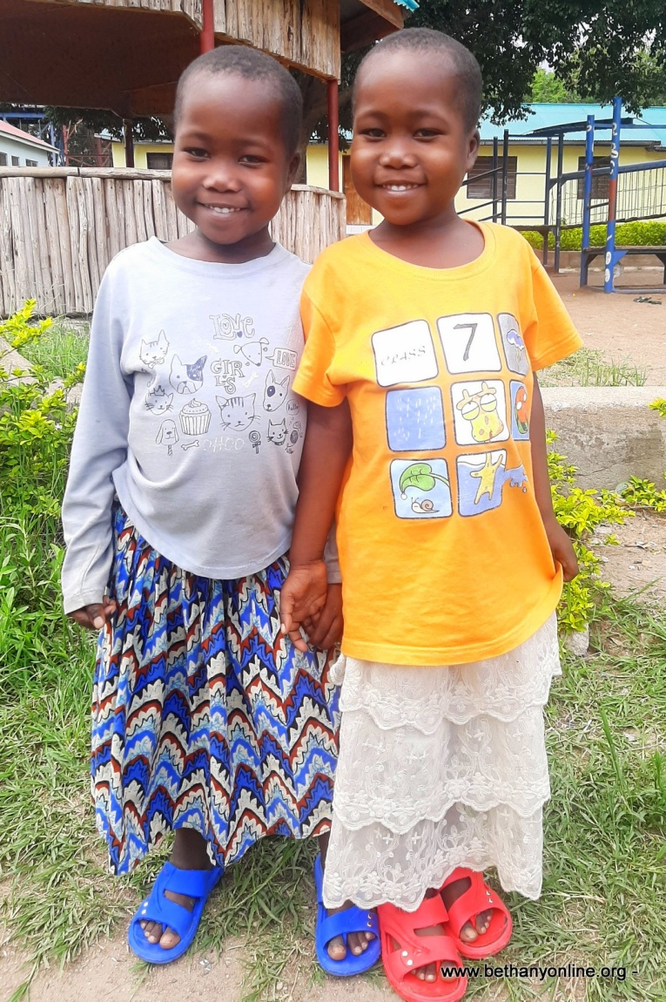

Dorren and Dorcas (twins) together with Edson and Edwin (twins) from the same family (10 children and mother)

