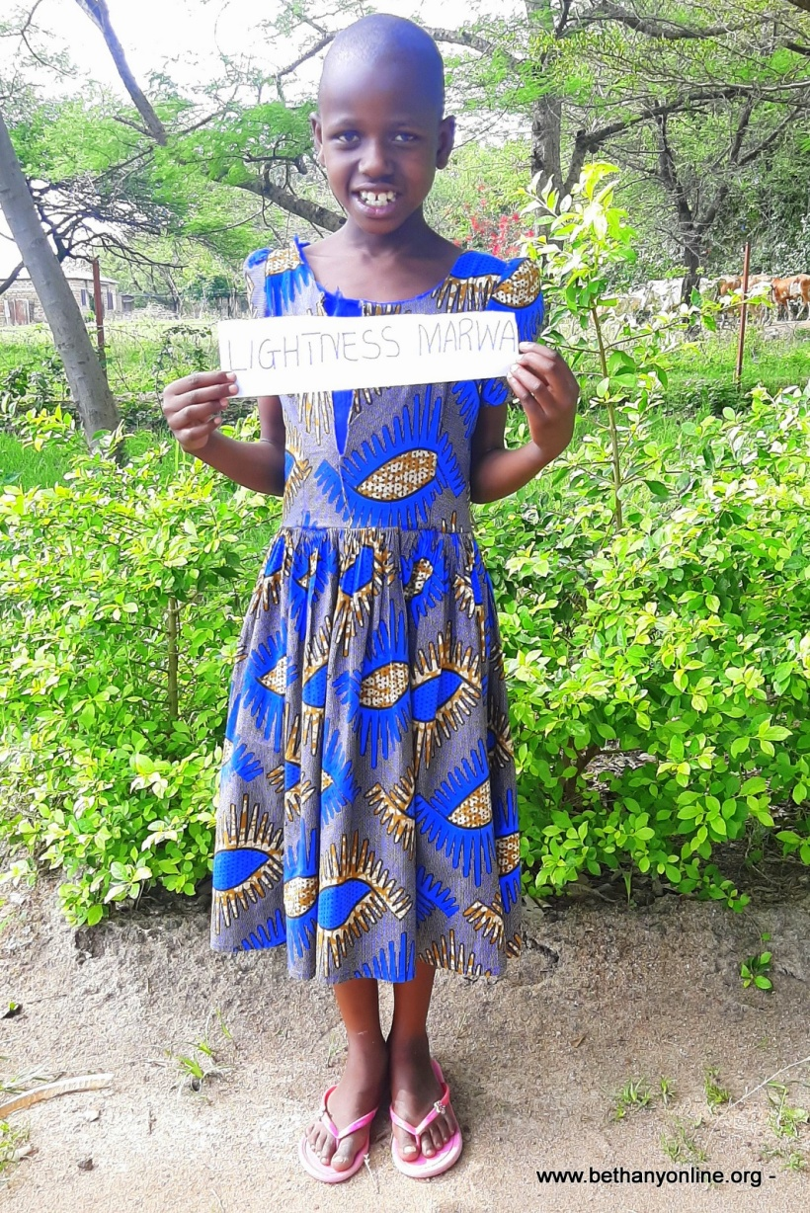
CHILD ADMISSION REPORT AT BETHANY

Full name: Lightness Marwa Sakara
Father’s name: Marwa Sakara
Mother’s name: Leticia Natori
Date of Birth: 25/11/2013
Date of Admission: 19/08/2020
Reason for admission: orphan
Favourite colour: Green
Tribe: Jita
Religion: Christian

Class: Toddlers

Favourite subject: Mathematics and English
Favourite ambition: Teacher
Favourite food: Ugali and Fish
Favourite drink: fanta orange
Best friend at Bethany: Aneth,
Sex: Female
Height: 133cm
Weight: 25kg
FAMILY HISTORY
Lightness lived with her mother at her grandmother’s place. Her mother who was jobless was responsible to provide for the family, so she spent her day in the village doing some small tasks and whatever she earned was to provide for the family’s basic needs. Lightness did not go to school, she stayed at home with her grandmother and sometimes went out with her mother to help her earn some money to provide for them. Her mother could not handle the situation that she decided to visit the social welfare’s office for help.
The social welfare made a call to Bethany and asked if we could take Lightness in. After some investigations, Lightness was admitted at Bethany and so she is living well and enjoys going to school though she has a long way to go before she fully settles in and gets used to the English language.

