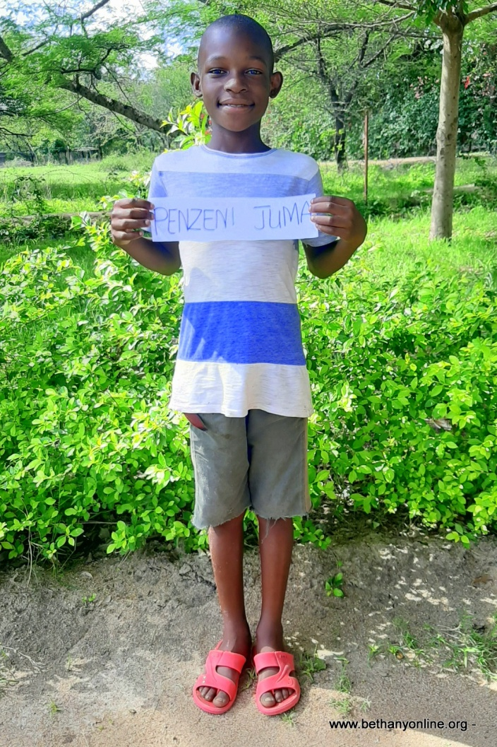
BRIEF HISTORY OF A CHILD’S ADMISSION AT BETHANY FAMILY.
Full name: Penzeni Yusuph James
Fathers Name: Yusuph James
Mother’s name: Nyasolo Elikana
Date of Birth: 31/07/2009
Place of Birth: Mwasamba
Date of admission: 01/07/2020
Reason of Admission: Abandoned
Standard: Standard one
Favourite Subject: Literacy & writing
Tribe: Sukuma
Favourite drink: Soda
Favourite colour: Blue
Best friend at Bethany:
Timotheo, Joshua & Jacob
Sex: Male
Religion: Christian
Height: 135 cm
Weight: 27kg
FAMILY HISTORY
Penzeni is one of the Bethany children since June 2020. Penzeni lived with both of his parents, and three other siblings. In 2018 the father abandoned the mother leaving her with all the children to look after, a situation which is very common for many families in Tanzania. The father was a drunkard who always beat up Pennzeni and his mother to the point where Penzeni wrote a very sad letter complaining about the treatment he got from his father and even wished him dead. After they were abandoned by his father, the mother tried her best to provide for Penzeni and his other three siblings but she could not handle it so one morning she took the younger child and abandoned the three other children without anyone to look after them. The children stayed for two days surviving only on porridge until a neighbour noticed the situation and reported it to the village leader. The village leader got in touch with Penzeni’s partenal grandfather who took the children in and tried his best to look after them since 2018 when they were abandoned. However, since the grandfather is also elderly and struggles to make ends meet, he tried to look for help and he was directed by the social welfare to approach Bethany.
Penzeni and his younger sister Annastazia were admitted at Bethany. They’ve both settled in the family, they go to school and enjoy being part of a big family. The grandfather has since been able to track their mother’s whereabouts but not their father.

