Brief history of a child’s admission into Bethany Family.
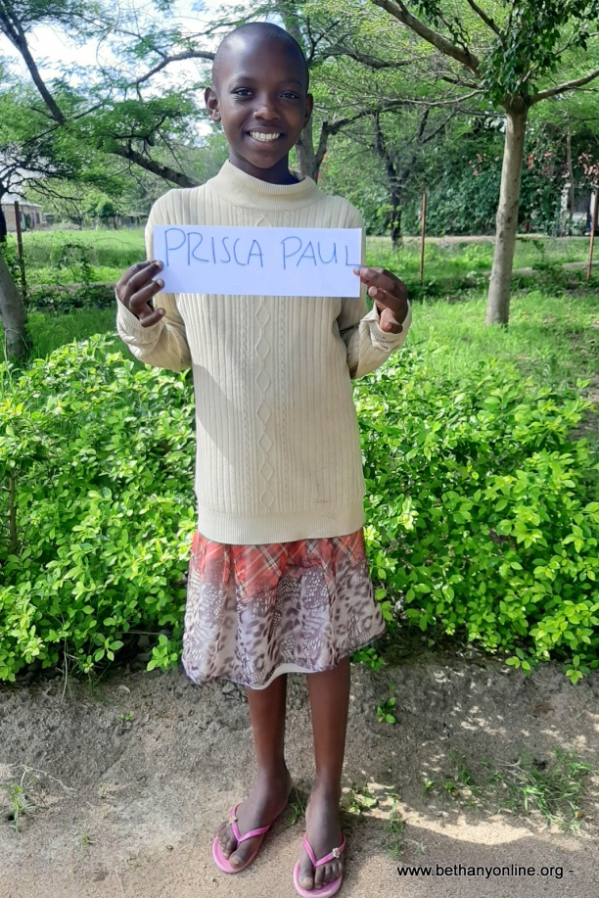
Full name: Prisca Paul Maharage
Fathers Name: Paulo Maharage
Mother’s name: Ruth Reuben
Date of Birth: 14/04/2010
Place of Birth: Sogesca
Date of admission: 21/02/2020
Standard: Year three
Favourite Subject: English
Tribe: Sukuma
Ambition: Nurse
Best food: Rice and Fish
Favourite drink: Juice
Favourite colour: Red, Pink & White
Best friends at Bethany:
Kulwa Masalu and Esther Juma
Sex: Female
Religion: Christian
Height: 147
Weight: 34
Family History
Prisca has two brothers and sisters. Her parents divorced due to misunderstanding in the family whereby it led children to separate, Prisca’s brothers went along with their father and she was left with her mother together with her two sisters. Prisca stayed with her mother for about six years. Prisca initially joined the Bethany school before she was admitted to Bethany for full support. On the 14thFebruary 2020, Prisca’s mother passed away due to an illness she had for about a year and Prisca was left under the custody of her oldest sister who also has very bad health issues and operates small businesses to get by because the father does not support them and has moved away from them. Due to Prisca’s mother’s death, her sister couldn’t afford to take care of Prisca and her other young sister called Angel. Therefore, they decided to ask for help at The Bethany family. Prisca was accepted and admitted at Bethany on 21/02/2020.
Prisca has settled well at Bethany and is also studying hard and doing well at school. She however suffers from pneumonia and other health conditions such as stomach ulcers. We have tried to take her to the doctors and have got some medications to help her cope with the situation and she has learnt to look after herself so that she can avoid these conditions from escalating.

