BRIEF HISTORY OF A CHILD’S ADMISSION AT BETHANY FAMILY.
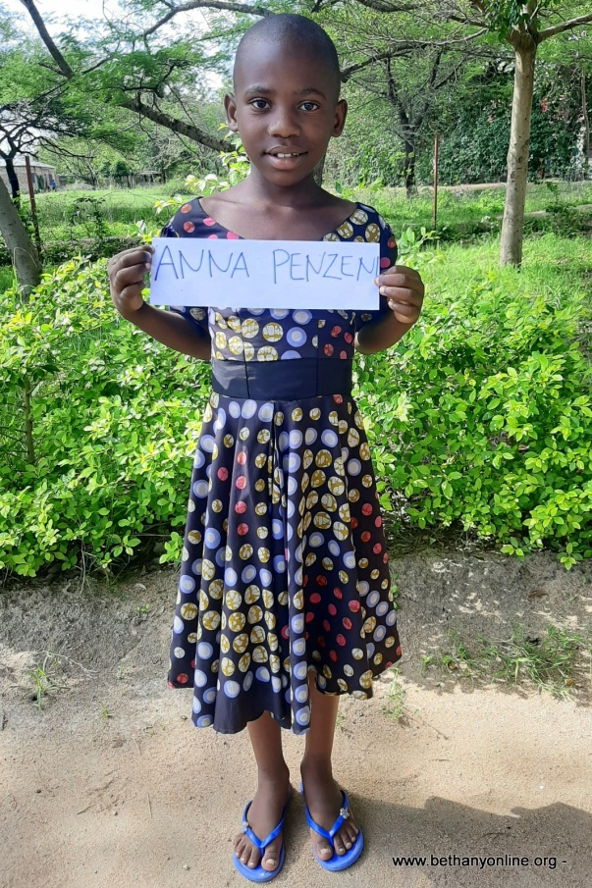
Full name: Anna Masumbuko Penzeni
Fathers Name: Masumbuko Penzeni
Mother’s name: Nyasolo Elikana
Date of Birth: 20/12/2013
Place of Birth: Mwasamba
Date of admission: 10/01/2020
Reason of Admission: Abandoned
Standard: Toddlers
Favourite Subject: Literacy & writing
Tribe: Sukuma
Favourite drink: Soda
Favourite colour: Blue
Best friend at Bethany: Monica Mashindano,
Sex: Female
Religion: Christian
Family history.
Anna is one of the Bethany children since January 2020. Anna lived with both of her parents, and three other siblings. In 2018 the father abandoned the mother living her with all the children to look after, a situation which is very common for most families in Tanzania. The father was a drunkard who always beat up Anna, her siblings and her mother severely. Anna, being one of the oldest sibling and a girl, had the job of cooking and looking after her young ones when her mother was not around and was at the Shamba (working in the field). Anna never attended school because she was the carer for her younger siblings. After they were abandoned by the father, the mother tried her best to provide for her family but she could not handle it. So one morning she took the younger child and abandoned the three other children without anyone to look after them. The children stayed for two days surviving only on porridge until a neighbour noticed the situation and reported it to the village leader. The village leader got in touch with some relatives who were around who got in touch with the social welfares in Busega to try and find a place for the three children to be looked after. Anna and her brother Penzeni were eventually admitted to Bethany, though it took time to admit Anna’s brother as he was already attending school and he needed to complete some documents for the transfer.
Anna and her brother have both settled in the family, they go to school and enjoy being part the Bethany’s family. Anna enjoys singing and helping others around such as Jennifer and those who can’t manage by themselves as she is used to looking after her young siblings. The other child was taken by the maternal grandmother because Bethany could not take all three children.

