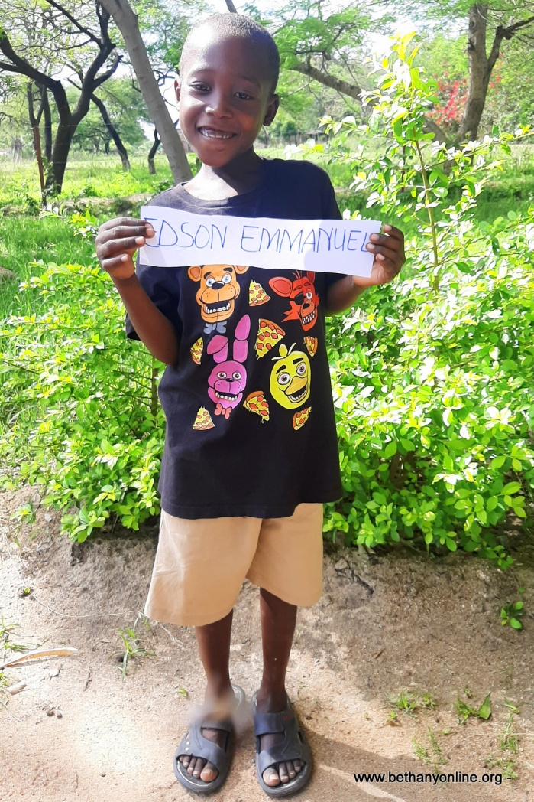
BRIEF HISTORY OF A CHILD’S ADMISSION AT BETHANY FAMILY.
Full name: Edson Emmanuel Helman
Fathers Name: Emmanuel Helman
Mother’s name: Kefleni Makoye
Date of Birth: 14/10/2012
Place of Birth: Busega (Buyorwa)
Date of admission: 01/11/2020
Reason of Admission: Orphan
Best colour: Yellow
Favourite food: Rice and Vegetables
Best friend: Emmanuel Masumbuko
Best subject: Numeracy
Tribe: Sukuma
Class: Toddlers
Sex: Male
Religion: Christian
Height: 120cm
Weight: 20kg
EDSON EMMANUEL HELMAN’S STORY (A NAME GIVEN TO HIM AT BETHANY)
Edson has a twin brother named Edwin at Bethany and another set of younger twin sisters (Dorca and Doreen). All four children are from the same parents. The mother has given birth to three sets of twins and four other children. Therefore, Edson is one of ten children, though one has passed away.
The mother lives in a very rural village next to Sogesca (where Bethany is) called Buyorwa. It is a place at the shore of the Lake Victoria and many people make their living through doing illegal fishing of small fish called sardines and other petty businesses. The place is overcrowded with very little for individuals to survive on.
Edson’s mother was married but her husband passed away few years ago because of HIV (a disease which is very common in this area). Therefore, she was left with all these children to look after. She is illiterate herself and only one of her children goes to school. The church nearby where Emmakulatha Zephaniah (Our Bethany Headteacher) and her husband attend every Sunday, started a programme of going around and identifying children and families which they could help provide something basic such as nutritious food, shelter etc and they discovered Edson’s family.
The pastor of the church helping these various families alongside Emmakulatha and her husband Zephaniah, went and saw the actual environment of these children and approached Miss Jesca Paulo (Bethany Project Director) and asked if we would be able to help this lady take care of some of her children. Miss Paulo did some investigations of her own and was convinced of the situation. Some pictures have been attached to the story for you to see the actual environment Edson and his fellow children were living in, and which her mother and other siblings are still living in as of today.
The children were very malnourished when they came to Bethany and were treated for things like roundworm and improved their diet. We are happy that they are settling into Bethany very well and coping with the environment. They have started going to school, though not officially but they are slowly getting into the routine and by next year, we’ll be able to register them officially and sort out their school uniforms etc.
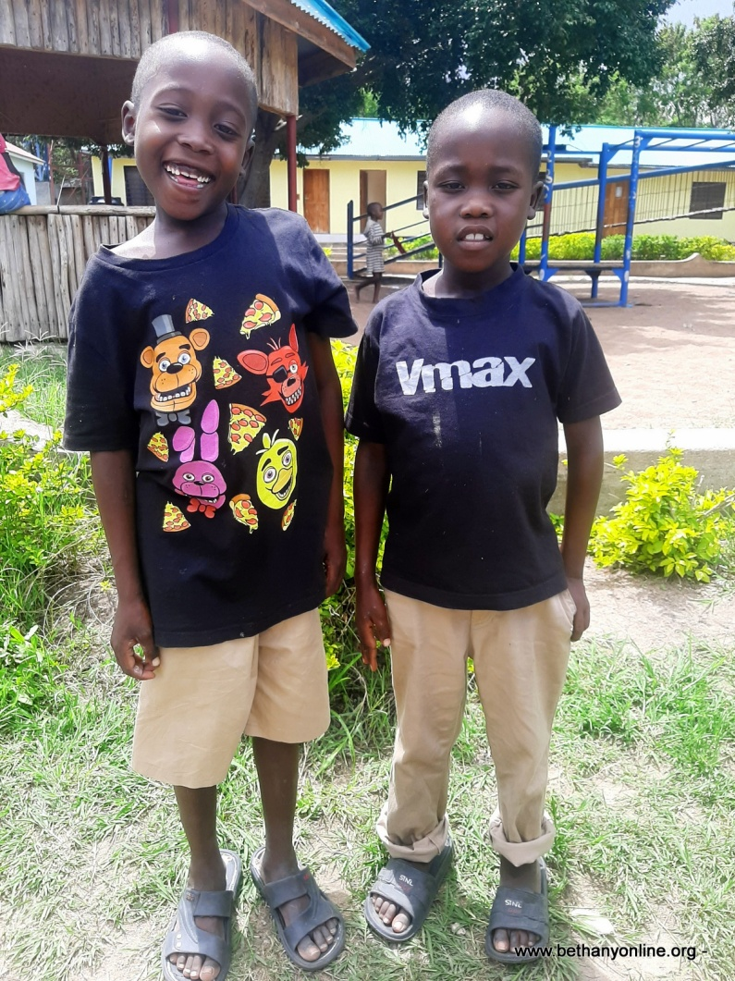
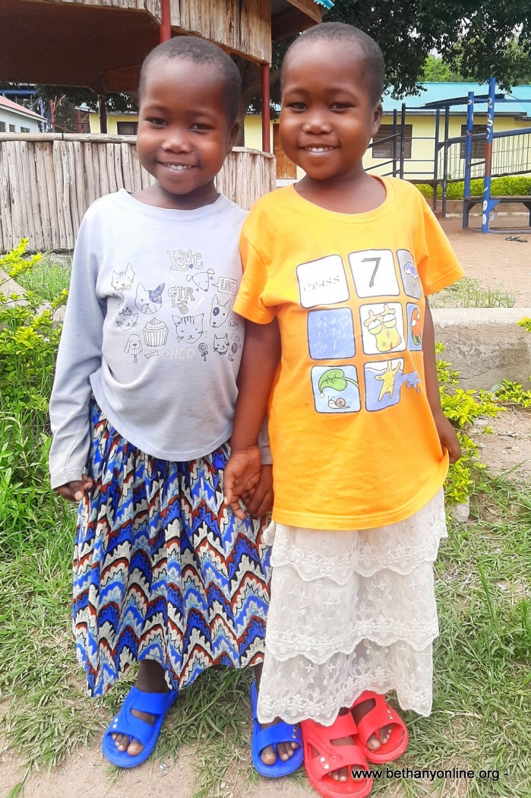

Edson and Edwin (twins) with Dorca and Doreen (twins) from the same family

