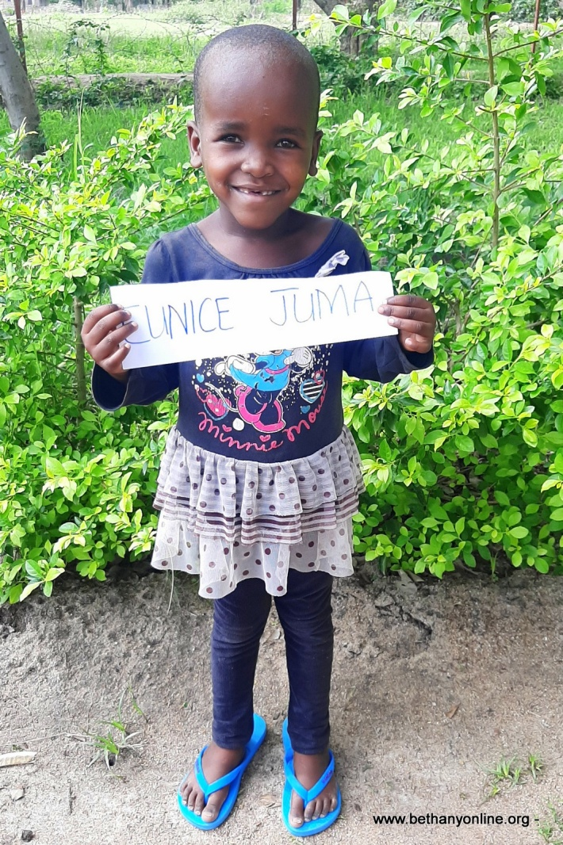
BRIEF HISTORY OF A CHILD’S ADMISSION AT BETHANY FAMILY.
Full name: Eunice Juma Peter
Fathers Name: Juma Peter
Mother’s name: Rose Julius Charahani
Date of Birth: 21/10/2014
Place of Birth: Sumve
Date of admission: 16/11/2020
Reason of Admission: abandoned
Favourite food: Ugali and dagaa
Best colour: Orange
Best friends: Rose Robert
Best subject: Numeracy
Tribe: Sukuma
Sex: Female
Religion: Christian
Height: 101cm
Weight: 13kg

EUNICE’S HISTORY:
Eunice has two sisters at Bethany, her twin sister Yulitha and younger sister Bertha. They are five in their family with two older brothers. All five children stayed with their mother without their father. Their father abandoned the mother when she was pregnant with Bertha, the younger sibling of the five children. Their mother was jobless and couldn’t take care of her children. She is a subsistence farmer who gets by with what she can grow when there’s enough rain. Eunice’s mother decided to abandon her children with her mother (Eunice’s grandmother). The grandmother was very poor and she couldn’t look after the children. One of the two older boys ran away when things got hard and went into the streets to beg. So Eunice’s grandmother sought for help from the village leader to directed her to the District’s social welfare who rang Bethany for help. Since the young children including Eunice, her twin sister Yulitha and younger sister Bertha, seemed to be most affected, Bethany decided to take all of them and admit them. All three children have settled in at Bethany and even though they are a little shy and don’t mix very much with others, but slowly they are getting into the routine.

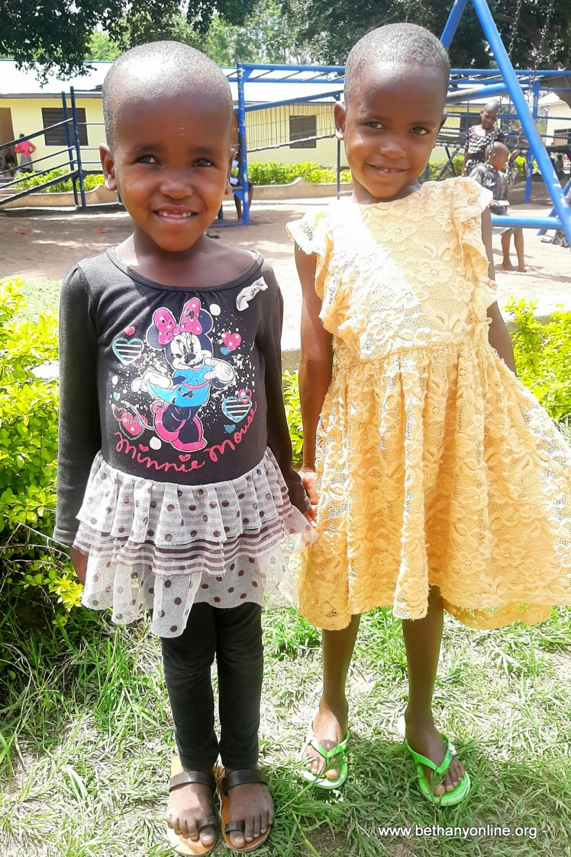

Eunice and Yulitha Juma

