BRIEF HISTORY OF A CHILD’S ADMISSION AT BETHANY FAMILY.
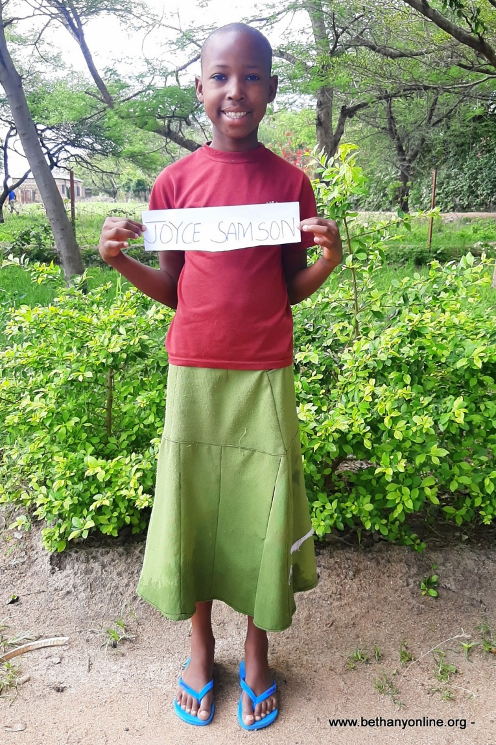
Full name: Joyce Samson Moris
Fathers Name: Samson Moris
Mother’s name: Elizabeth
Date of Birth: 05.06.2010
Place of Birth: Magu Isandula
Date of admission: 05.07.2020
Reason of Admission: Abandoned
Standard: Year Two
Favourite Subject: Math & science
Ambition: Nurse
Tribe: Sukuma
Best food: Rice and Meat
Favourite drink: Soda
Favourite colour: Pink
Best friend at Bethany:
Mariam Bwire, Monica Mashindano, Angel Maige
Sex: Female
Religion: Christian
Height: 138cm
Weight: 28kg

Family history.
Joyce Samson is 11 eleven-years-old. Joyce stayed with her grandmother in a remote village in Magu District. Joyce’s father abandoned her mother at pregnancy. After giving birth, her mother also abandoned her at her grandmother’s place and was never seen or heard of since.
Joyce grew up with her grandmother who was jobless and had health problems thus faced difficulties in providing and caring for her granddaughter. Joyce initially joined the Bethany school, however, when we later found out about her living conditions were very hard the we decided to admit her into the children’s home. Therefore, her grandmother invited the social welfare in her village and they reported to us about the problems Joyce faced and how we could help. After consideration, Joyce was admitted at Bethany and is now happy and enjoys life with other children and continues with school.
Joyce enjoys singing gospel songs and she is very confident young lady who can stand up in front of the other children and sing solo. She has since joined the Bethany’s choir as well and enjoys singing with others.
We have recently found out that Joyce suffers from asthma, a fact we were never told by her grandmother, but we thank God that she is coping very well and keeps herself warm during windy and cold weather conditions. Joyce is very well behaved towards care workers and her fellow children. Since she’s been at Bethany, no one has ever complained about Joyce. We hope and pray that Joyce continues with such attitude as she learns more about Christ Jesus and his purpose for her life.

