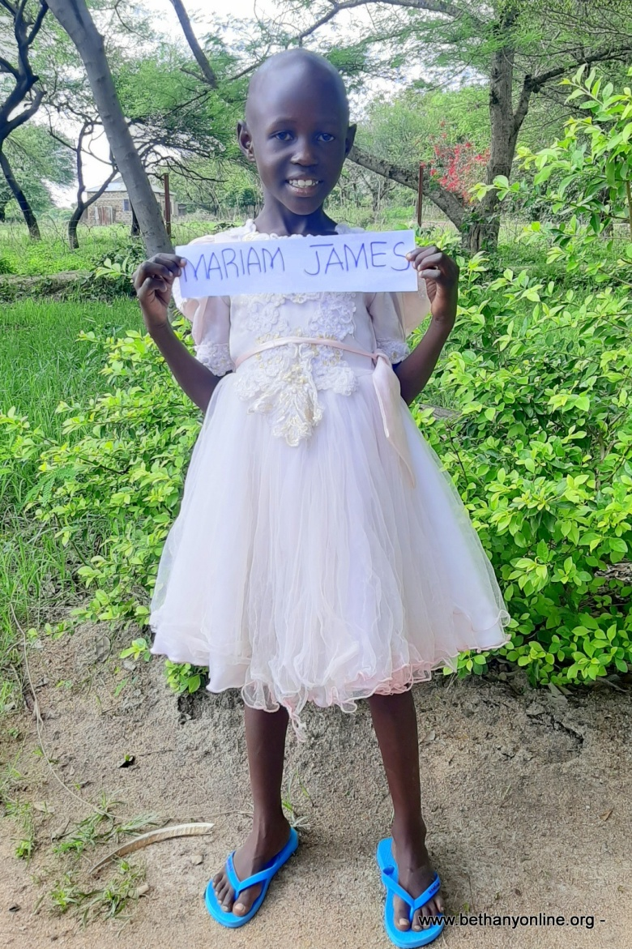
BRIEF HISTORY OF A CHILD’S ADMISSION AT BETHANY FAMILY.

Full name: Mariam James Malegi
Fathers Name: James Malegi
Mother’s name: Catherine Zabron Kabaya
Date of Birth: 02/05/2013
Place of Birth: Magu Itumbili
Date of admission: 16/11/2020
Reason of Admission: Abandoned
Best food: Ugali and fish
Best colour: White
Best friends: Anna Yusuph
Best subject: Mathematics
Class: Standard one
Ambition: Teacher
Tribe: Sukuma
Sex: Female
Religion: Christian
Height: 117cm
Weight: 17kg

MARIAM’S HISTORY:
Mariam has both parents with the father being HIV positive. Mariam’s parents have three other children including Mariam which makes a total of four in their family. There are two boys and two girls, Mariam being the third born in the family.
Mariam’s parents are both illiterate and depend on farming for their survival and that of their children. They have tried their best to look after the children but with Mariam’s father being HIV positive, he struggles to keep up and do other tasks to keep his family going. He has tried to ask for help from relatives to give him assistance in looking after the children with very little success.
He spoke to someone who knows Bethany and that person directed him to us. However, we had to ring the social welfare to confirm the situation. The social welfare confirmed Mariam’s background as her parents receive a little help from the government as well to help them with the basics. Mariam was accepted at Bethany and she is now a happy little girl, receiving all her basic needs and a great education.

